Geometry Common Assessment 2 Review Fayette County Public Schools

Question Number | Question
1 | If m∠NOP = 39° and m∠NOQ = 142°, what is m∠POQ?  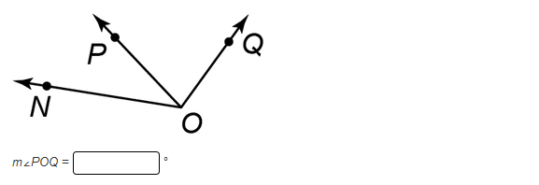
2 | What is the value of x?  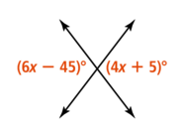
3 | Name all pairs of alternate interior angles?  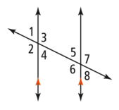
₄ | If g || h and m $<$ 2 = 67$°$ , what is m < 5?  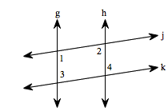  5
5 | Which equation represents a line perpendicular to $y=4x+12$. Select all that apply.  - $4x-y= -12$  - $y=\frac{1}{4}x+12$  - $y=-\frac{1}{4}x-3$  - $x+4y=12$
6 | If point A has coordinates (5,-3), what are the coordinates if it is reflected across the  y-axis?
7 | What translation rule maps ΔRST to ΔR’S’T’?  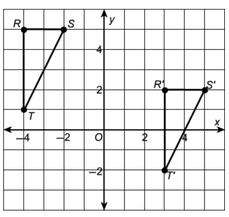
8 | ΔXYZ had coordinates X(4,7), Y(6,3), Z(1,1). What are the coordinates of Y’ after T_{<-3, 5>}?
9 | 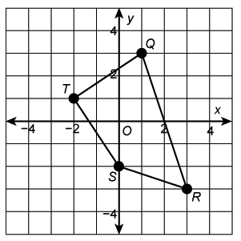  Use quadrilateral QRST.  What are the coordinates of Q’ after the  quadrilateral is rotated 90$°$ about the origin?
10 | Use quadrilateral QRST above in #9.  What are the coordinates of R’ after the  quadrilateral is rotated 270$°$ about the origin?
11 | How many lines of symmetry does a regular octagon have?
12 | Which upper case letters of the alphabet have rotational symmetry?
13 | ΔABC is reflected across the x-axis creating ΔA’B’C’. Are the triangles congruent? Justify your answer.
14 | 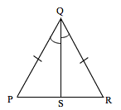  What is m<QRP if m<PQS = 27$°$?
15 | If the m<QSP = 90$°$, PQ = 20, and PS = 12, what is QS?
16 | What criterion can be used to prove the triangles congruent?  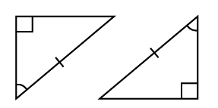
17 | What is the value of x?  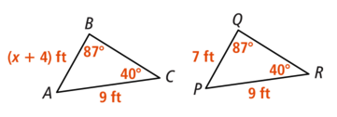
18 | List all the ways to prove triangles congruent.
19 | What theorem can be used to prove the triangles congruent?  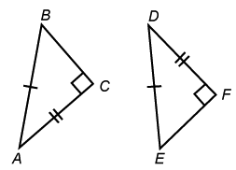
20 | 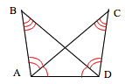  Which side is congruent to $\overline{BD}$?

