Four Types of Slope
$$y=5x-2$$ | x does not increase or decrease; rather, y takes every possible value at a specific x value | 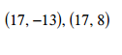 | 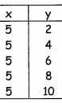 | 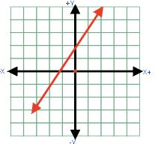
$$2y-5=0$$ | 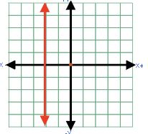 | y always decreases when x increases and  y always increases as x decreases | $$x=4$$ | As x increases or decreases, y does not change; x takes on every possible value at a specific y value
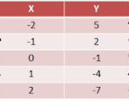 | 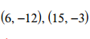 | Free Space  4 Types of Slopes  Positive  Negative  Zero  No Slope | $$4y+x=12$$ | 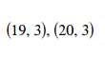
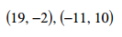 | $$y=-3x-5$$ | 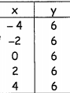 | 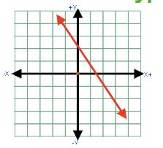 | $$3x+6=0$$
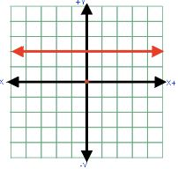 | $$-2x+3y=4$$ | $$y=-2$$ | y always increases when x increases and  y always decreases when x decreases | 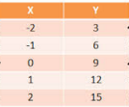
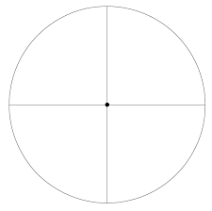
Zero
Undefined

Negative
Positive
Take turns.
Spin the spinner.
Place a marker on one of the corresponding pictures on the game board.
Get 4 in a row and WIN!

