Topic 4 Review Name:
Geometry Date:

4.1: Congruence
1. Which of the following statements is true?
A △JKL ≅ △MNO
B △JKL ≅ △PQR
C △STU ≅ △MNO
D △STU ≅ △JKL

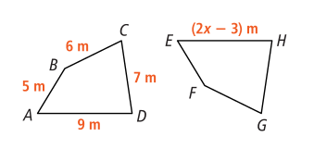
2. Given ABCD ≅ EFGH, find the value of x.

4.2: Isosceles and Equilateral Triangles
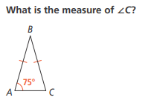
3. 4. Find the unknown angle measures for each
triangle.
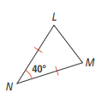
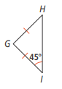

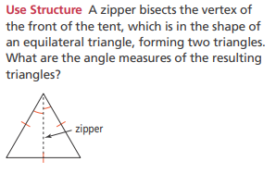
5. 6. Find the lengths of all three sides of each
triangle.
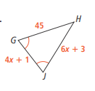
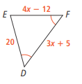

4.3 – 4.6: Congruent Triangles

State whether each pair of triangles is congruent by SAS, SSS, ASA, AAS, HL, or the congruence cannot be determined.
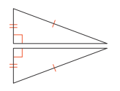
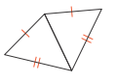
6. 7. 8.
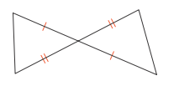

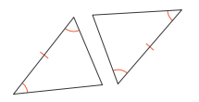
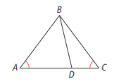
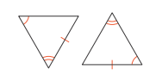
9. 10. 11.

12. Given: $\overline{VX}≅\overline{VZ}$
Y is the midpoint of $\overline{XZ}$
∠WYX ≅ ∠AYZ

Prove: $\overline{WY}≅\overline{AY}$

Statement | Reason

13. Given: $\overline{MW}$ $\overline{SP}$
$\overline{SW}≅\overline{WP}$

Prove: $∆SMW≅∆PMW$

Statement | Reason

B
A
14. Given: $\overline{AB}≅\overline{DC}$
$\overline{AC}≅\overline{DB}$
D
C
Prove: $∆ABC≅∆DCB$

Statement | Reason

