5.1 Perpendicular and Angle Bisectors Name:
Adv. Geometry Date:

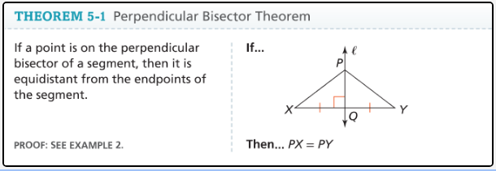

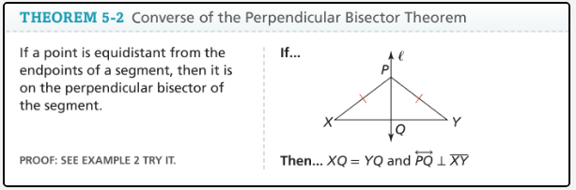

A point that is the same distance from two points is equidistant from the points.

Example 3:


Example 4 - Applying the Perpendicular Bisector Theorem:

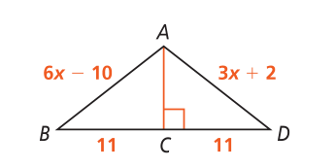
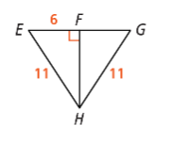
What is the value of AD? What is the value of FG ?

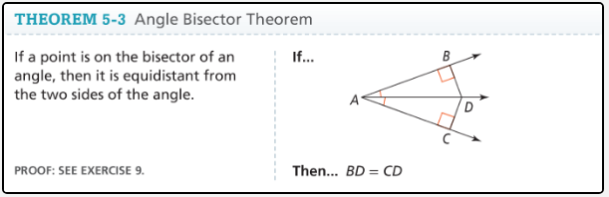

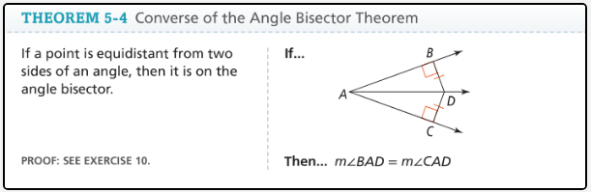

Example 6: What is the value of KL?
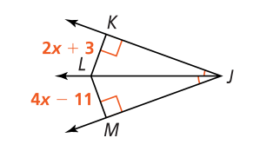

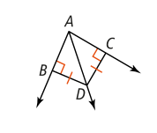
You Try:


