2.2 Notes Supplement Name:
Proving Lines Parallel

Example 1:

Suppose two lines are not parallel. Can corresponding angles still be congruent?
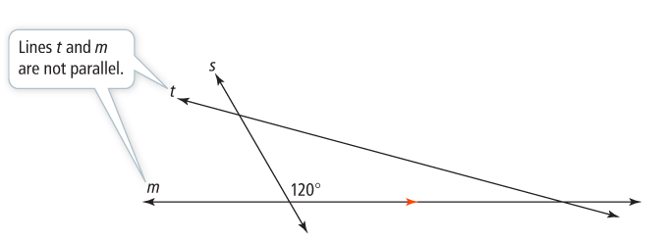

Could <3 be supplementary to a $120°$ angle?

-------------------------------------------------------------------------------------------------------------------------------------------------
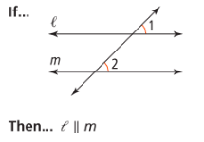
Theorem 2-4: Converse of the Corresponding Angles Theorem
______________________________________________________

______________________________________________________

______________________________________________________
-------------------------------------------------------------------------------------------------------------------------------------------------
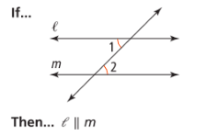
Theorem 2-5: Converse of the Alternate Interior Angles Theorem
______________________________________________________

______________________________________________________

______________________________________________________

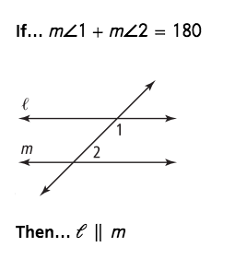
-------------------------------------------------------------------------------------------------------------------------------------------------
Theorem 2-6: Converse of the Same-Side Interior Angles Theorem
______________________________________________________

______________________________________________________

______________________________________________________
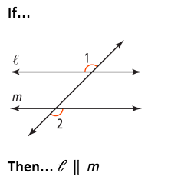
-------------------------------------------------------------------------------------------------------------------------------------------------
Theorem 2-7: Converse of the Alternate Exterior Angles Theorem
______________________________________________________

______________________________________________________

______________________________________________________
Example 3: Determine Whether Lines are Parallel
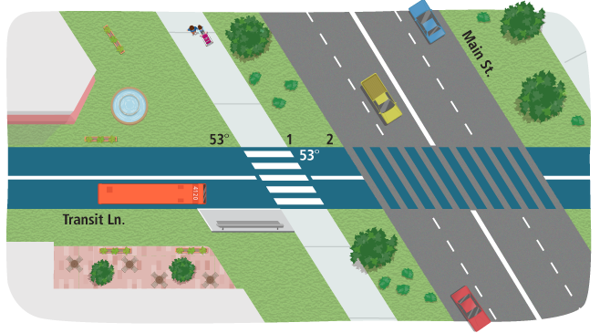

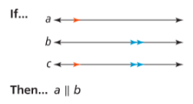
-------------------------------------------------------------------------------------------------------------------------------------------------
Theorem 2-8:
__________________________________________________________

__________________________________________________________
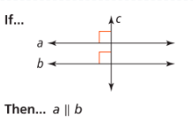
-------------------------------------------------------------------------------------------------------------------------------------------------
Theorem 2-9:
__________________________________________________________

__________________________________________________________

-------------------------------------------------------------------------------------------------------------------------------------------------
Example 4:


