Geometry Name:
1.3 Notes Supplement
Midpoint & Distance

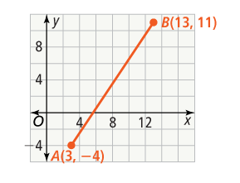
Example 2:

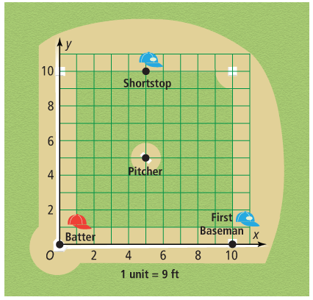

Example 4:

