FCPS Review GCA 1

Question Number | Question
1 | If FN=90, what is the value of r?  4r+5  3r+15  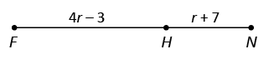
2 | Point P is in the interior of ∠NOQ. If m∠NOP = 42° and m∠NOQ = 156°, what is m∠POQ?  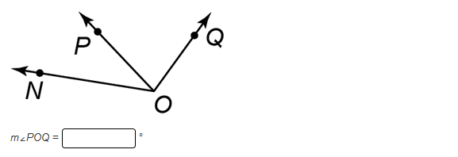
3 | The angle bisector of ∠ABC is BE. IF m∠ABE = 3x°, what is m∠ABC?  - x°  - 3x°  - 6x°  - 12x°
4 | What is the distance between points A(3, 7) and B(-3, 5)? Round to the nearest whole number.
5 | 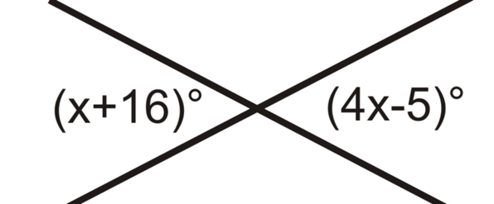  What is the value of x?
6 | 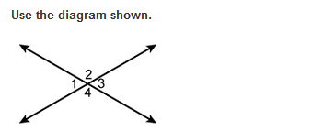  Name all linear pairs:  Name all vertical angles:
7 | What do we know about parallel lines?  What do we know about perpendicular lines?
8 | 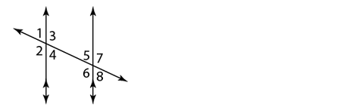  Which pairs of angles are:  Vertical Angles:  Linear pair:  Corresponding:
9 | Use the parallel lines shown for question 9 and 10.  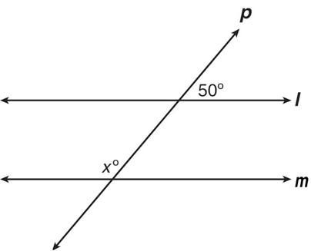  y°  What is the m∠x?
10 | What is the m∠y?
11 | 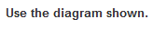  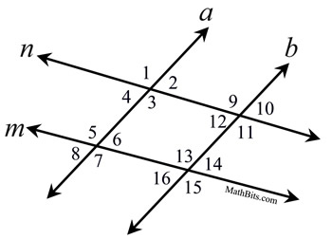  If m∠1 ≅ m∠5, which conclusion can be made?
12 | If m∠1 ≅ m∠9, which conclusion can be made?
13 | If a is parallel to b m∠1 = 52°, what is the m∠5?
14 | 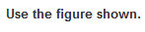  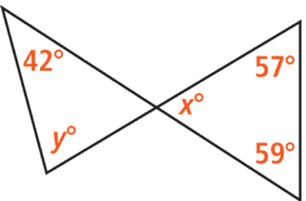  What is the value of x?
15 | 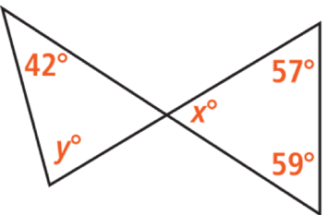  What is the value of y?
16 | Use the triangle shown.  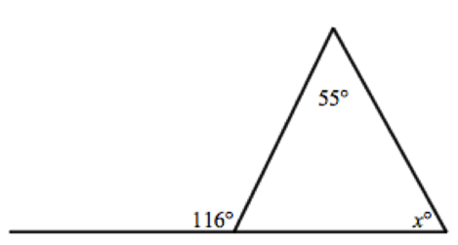  What is the value of x?
17 | Use the triangle shown.  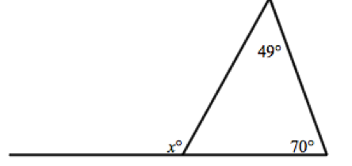  What is the value of x?
18 | If a is parallel to b and the slope of line a is 6, what is the slope of line b?
19 | What is the equations of a line that is perpendicular to the line y = $-\frac{3}{5} x+2$ and passes through the point (-2, 1)?
20 | Which equation represents a line that is parallel to the line with the equation y = 5x + 9? Select all that apply  - y = -5x +2  - y = 5x -1  - -5x + y = 4  - 5x + y = 6  - -5x – y = 2

