Grade 8 Topic 2 Online Assessment (question print out)
Name: _____________________________

1.
Cecile packages snack mix at a health food store.
She uses of her supply of sunflower seeds to make a salted snack mix and of her supply to make an unsalted snack mix. If Cecile uses 10 pounds of sunflower seeds, how many pounds of seeds are in her supply?

- 18 pounds
- 23 pounds
- 30 pounds
- 40 pounds

2.
Which statement is true? Select all that apply.
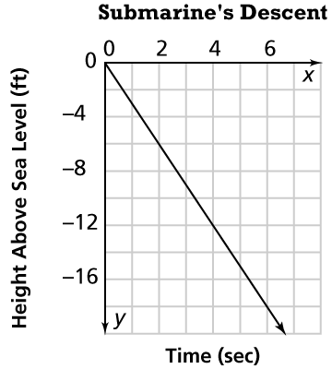

- The relationship is proportional.
- The slope is –6.
- The slope is negative.
- The y-intercept is –3.
- The equation of the line is y = –3x.

3.
The graph shows the volume of water in a sink x minutes after the faucet is turned on.
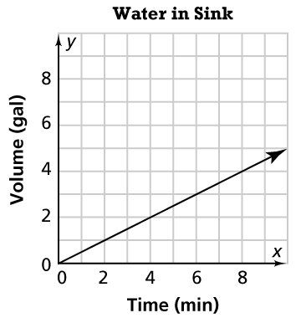
Part A
What is the slope of the line?
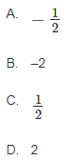

Part B
Connor says the graph shows that water is flowing at a rate of 2 gallons per minute. Is he correct? Use the drop-down menus to explain your answer.

Connor correct because the rate of water flowing is the slope.
is not greater than
is less than
equal to

Water is flowing at a rate that is 2 gallons per minute.
greater than
equal to
less than

4.
What is the solution to this equation?
–0.2(x – 20) = 44 – x
- x = –90
- x = –50
- x = 50
- x = 90
5.
A public parking garage charges $5, plus an additional $2 per hour.
Part A
Drag numbers to complete the equation for the line in slope-intercept form. Numbers may be used once, more than once, or not at all

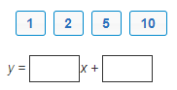

Part B
Choose the graph of the line.

A. 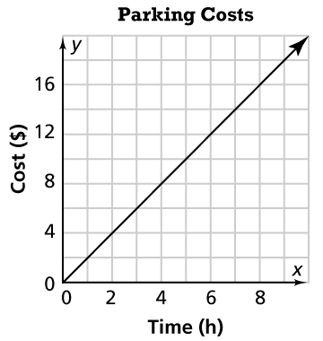 B. 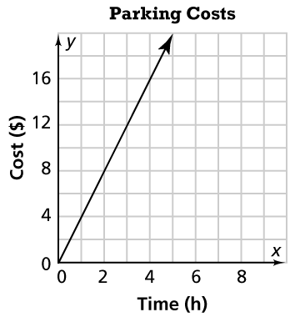

- C. 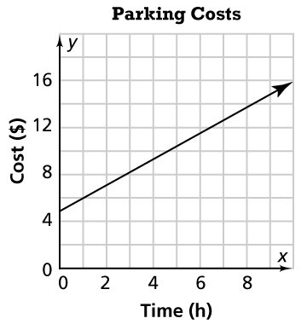 D. 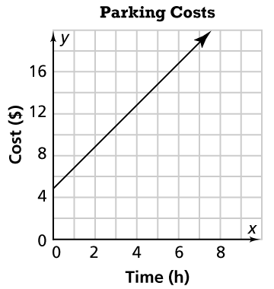

6.
Drag the tiles to match each equation to its number of solutions. Each tile may be used only once.

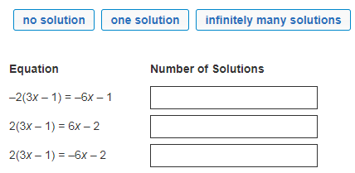

7.
Solve this equation.
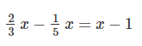
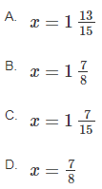

8.
Khalid and Jesse took different overnight trains.
The graph shows the relationship between the total distance Khalid traveled and the time in hours.
The distance Jesse traveled after x hours is given by the equation y = 150x. Who, if anyone, traveled at a faster speed?
Use the drop-down menus to explain your answer.
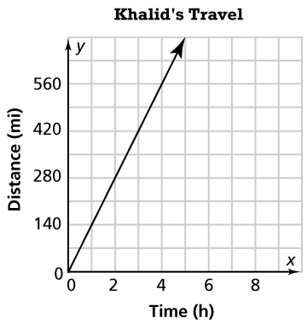
Khalid’s rate is miles per hour. Jesse’s rate is miles per hour.
140 140
120 280
150 120
280 150

So, train traveled at a faster speed.
Khalid’s
Jesse’s
Neither

9.
Maria is renting kayaks from a local shop that charges a $10 fee, plus an hourly rate of $7.50.
For how long can Maria rent the kayak if she pays a total of $70?
A. 6 hours
B. 7 hours
C. 8 hours
D. 9 hours

