Grade 7 Topic 2 Online Assessment (question print out)
Name: _____________________________
1.
The equation y = 5.5x represents a proportional relationship. What is the constant of proportionality?
- X
- Y
- 5.5
2.
The tables show the numbers of white and yellow flowers Cara and Hector used in 5 different arrangements.
Cara's Flower Arrangements
White | 3 | 6 | 9 | 12 | 15
Yellow | 5 | 10 | 15 | 20 | 25

Hector's Flower Arrangements
White | 4 | 8 | 12 | 16 | 20
Yellow | 6 | 10 | 14 | 18 | 22

Part A
Are the numbers of white and yellow flowers in Cara's arrangements proportional?
Which equation relates the number of white flowers, w, to the number of yellow flowers, y?
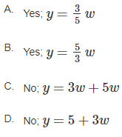
Part B
Are the numbers of white and yellow flowers in Hector's arrangements proportional?
Write an equation to relate the number of white flowers, h, to the number of yellow flowers, e.
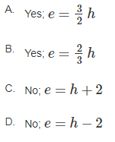
3.
The graph shows how many bottles a machine caps in a certain number of seconds.
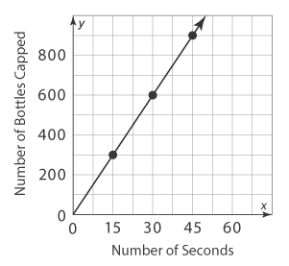
Part A
What is the constant of proportionality, and what does it mean in this situation?
Use the drop-down menus to show and explain your answer.

15 15 1 second
20 20 15 seconds
30 30 1 minute

Part B
Which of the following is an ordered pair on the graph? What does it represent in this situation?

- (45, 90); the machine caps 45 bottles in 90 seconds.
- (45, 900); the machine caps 45 bottles in 900 seconds.
- (45, 900); the machine caps 900 bottles in 45 seconds.
- (900, 45); the machine caps 900 bottles in 45 seconds
4.
Natalie walked mile in hour. How fast did she walk, in miles per hour?

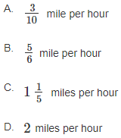
5.
Sarah used 2.5 cups of cheese in a dish that serves 10 people. Amyn used 1.6 cups of cheese in a dish that serves 8 people. How much more cheese is in one serving of Sarah's dish?

- 0.5 cup
- 0.25 cup
- 0.2 cup
- 0.05 cup

6.
A garden hose fills a 2-gallon bucket in 5 seconds.
The number of gallons, g, is proportional to the number of seconds, t, that the water is running.
Which equation represents the relationship between g and t? Select all that apply.
- g = 0.4t
- t = 0.4g
- g = 2.5t
- t = 2.5g
- 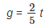
7.
Henry is making a corn grits recipe that calls for cup of corn grits for every cup of water.
How much water will he need if he uses cups of corn grits? Enter the number in the box.

cups of water

8.
At the local bakery, Ariel bought 2 oatmeal cookies for $1.50. Mei bought 12 dozen oatmeal cookies for $4.50.
Becky bought 8 oatmeal cookies for $6.00.
Part A
Which graph represents the situation?
A.
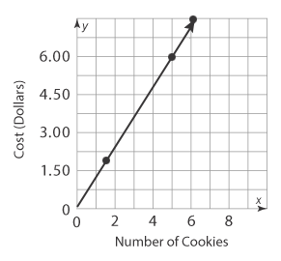
B.
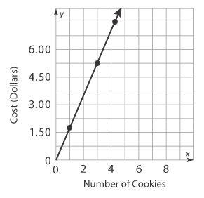
C.
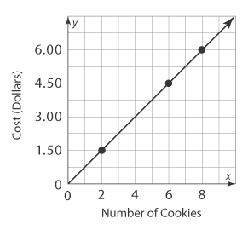
D.
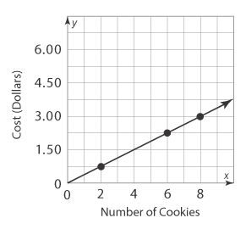

Part B
Look at the graph you chose in Part A. Do the number of cookies and the cost have a proportional relationship?
Use the drop-down menus to show and explain your answer.

Yes is point (0,1)
No is not point (1,0)
origin

Part C
What does the point (1, 0.75) represent in this situation? What does the point (0, 0) represent?

- 1 cookie costs $0.75; no cookies cost $0
- 1 cookie costs $7.50; no cookies cost $0
- 0.75 dozen cookies cost $1; 0 dozen cookies cost $0
- 1 dozen cookies cost $0.75; 0 dozen cookies cost $0

