Adv Geometry
2-4 Supplement - Slopes of Parallel and Perpendicular Lines

Example 1:
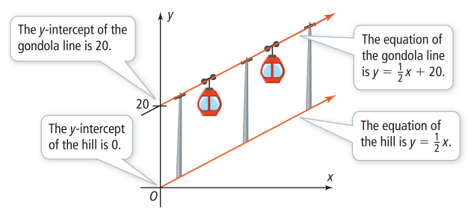

Theorem 2-13:

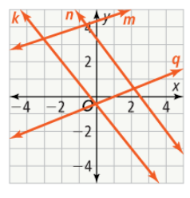
Example 2:

Theorem 2-14:

Example 3:
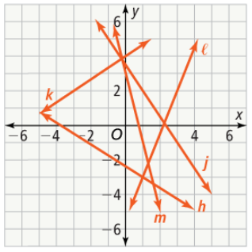

Example 4:


