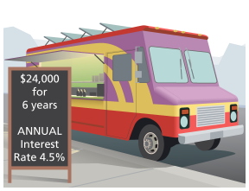
Example 6 Use a Finite Geometric Series
Isabel wants to borrow $24,000 for 6 years with an annual interest rate of 4.5% to purchase a share in a food truck business. What will be her monthly payment?

6-7 Geometric Sequences and Series

I can identify, write, and use geometric sequences and series.

Essential Question: How can you represent and use geometric sequences and series?

A _________________________________________ sequence is a sequence with a constant ratio between consecutive terms. This ratio is called the __________________________________________________, r.

Example 1 Identify Geometric Sequences

A. Is the sequence shown in the table a geometric sequence? If so, write a recursive definition for the sequence.
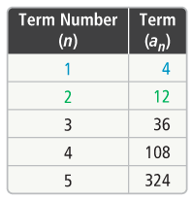

B. Is the sequence 12, 9.6, 7.68, 6.144, … a geometric sequence? If so, write the recursive definition for the sequence.

Example 2 Translate Between Recursive and Explicit Definitions
A. Given the recursive definition $a_{n}=\left\{\begin{matrix}5, n=1 \\ a_{n-1}\left(\frac{1}{2}\right), n>1\end{matrix}\right.$, what is the explicit definition for the geometric sequence?

B. Given the explicit definition $a_{n}=3{\left(2\right)}^{n-1}$, what is the recursive definition for the geometric sequence?

Example 5 Number of Terms in a Finite Geometric Series
A. How many terms are in the geometric series $200+300+450+…+7,688.7$?

B. The sum of a geometric series 11,718. The first term of the series is 3, and its common ratio is 5. How many terms are in the series?

Example 3 Solve Problems With Geometric Sequences

A phone tree is when one person calls a certain number of people, then those people each call the same number of people, and so on. In the fifth round of calls, 243 people were called.

A. Write an explicit definition to find the number of people called in each round.

B. How many people were called in the eighth round of the phone tree?

A geometric _______________________ is the sum of the terms of a geometric sequence. $S_{n}$ represents the sum of a geometric sequence with n terms.

Example 4 Formula for the Sum of a Finite Geometric Series
A. How can you find the sum of a finite geometric series?

B. Write the expanded form of the series. What is the sum?

$$\sum_{n=1}^{7}{3{\left(\frac{2}{3}\right)}^{n-1}}$$



