Example 6 Solve Logarithmic and Exponential Equations by Graphing
What is the solution to $\log{{\left(2x+1\right)}^{5}=x-2}$?

6-6 Exponential and Logarithmic Equations
I can solve exponential and logarithmic equations

Essential Question: How do properties of exponents and logarithms help you solve equations?

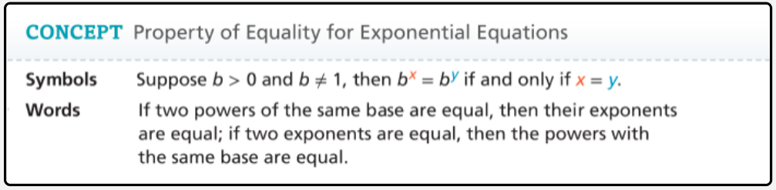

An ________________________________________________________ is an equation that contains variables in the exponents.

Example 1 Solve Exponential Equations Using a Common Base
What is the solution to ${\left(\frac{1}{2}\right)}^{x+7}=4^{3x}$?

Example 2 Rewrite Exponential Equations Using Logarithms
How can you rewrite the equation $17=4^{x}$ using logarithms?

A ________________________________________________________ contains one or more logarithms of variable expressions.

Example 5 Solve Logarithmic Equations
What is the solution to $\ln{(x^{2}-16)}=\ln{(6x)}$?

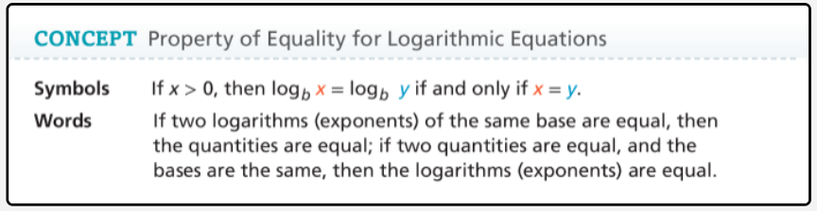

Example 3 Solve Exponential Equations Using Logarithms
What is the solution to $3^{x+1}=5^{x}$?

Example 4 Use an Exponential Model
The diagram shows how a forest fire grows over time. The fire department can contain a 160-acre fire without needing additional resources. About how many minutes does it take for a fire to become too big for the fire department to contain without additional resources? Round to the nearest minute.


