6-5 Properties of Logarithms

I can use properties of logarithms to rewrite expressions.

Essential Question: How are the properties of logarithms used to simplify expressions and solve logarithmic equations?

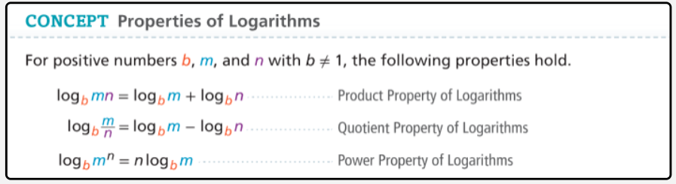

Example 1 Prove a Property of Logarithm
How can you prove the Product Property of Logarithms?

Example 2 Expand Logarithmic Expressions
How can you use the properties of logarithms to expand each expression?
A. $\log_{5}{(a^{2}b^{7})}$

B. $\ln{(\frac{25}{3})}$

Example 3 Write Expressions as Single Logarithms
What is each expression written as a single logarithm?
A. $4\log_{4}{m}+3\log_{4}{n}-\log_{4}{p}$ B. $3\ln{2}-2\ln{5}$

Example 4 Apply Properties of Logarithms
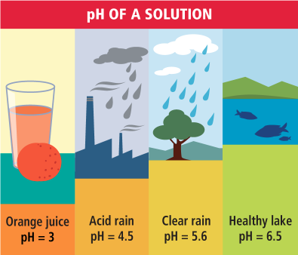
The pH of a solution is a measure of its concentration of hydrogen ions. This concentration (measured in moles per liter) is written [H⁺] and is given by the formula $pH=\log{\frac{1}{[H^{+}]}}$. What is the concentration of hydrogen ions in the acid rainfall?

Example 5 Evaluate Logarithmic Expressions by Changing the Base
How can you use base 10 logarithms to evaluate base 2 logarithms?

This illustrates the _________________________________________________________.

Example 6 Use the Change of Base Formula
What is the solution of the equation $2^{x}=7$? Express the solution as a logarithm and then evaluate. Round to the nearest thousandth.



