6-4 Logarithmic Functions

I can graph logarithmic functions and find equations of the inverses of exponential and logarithmic functions.

Essential Question: How is the relationship between logarithmic and exponential functions revealed in the key features of their graph?

Example 1 Identify Key Features of Logarithmic Functions
Graph $y=\log_{2}{x}$. What are the domain, range, x-intercept, and asymptote? What is the end behavior of the graph?
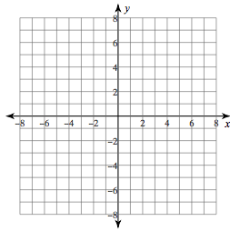
Domain:
Range:
x-intercept:
Asymptote:
End behavior:

Example 2 Graph Transformations of Logarithmic Functions
Graph the function. How do you know the asymptote and x-intercept of the given function compare to those of the parent function?
$$g\left(x\right)=\log_{2}{(x+3)}$$

Example 3 Inverses of Exponential and Logarithmic Functions
What is the equation of the inverse of the functions?
A. $f\left(x\right)={10}^{x+1}$
B. $g\left(x\right)=\log_{7}{(x+5)}$

Example 4 Interpret the Inverse of a Formula Involving Logarithms
A company uses this function to relate sales revenue R and advertising costs, a:
$$R=12\log\left(a+1\right)+25$$
What is the equation of the inverse of the formula? Which equation would be easier to use to find a value of a for a particular value of R?

Example 5 Compare Two Logarithmic Functions
Logarithmic functions can approximate the altitude of a plan over time. Which plane’s altitude shows the greater rate of change over the interval $10≤t≤15$?


