6-3 Logarithms

I can evaluate and simplify logarithms.

Essential Question: What are logarithms and how are they evaluated?

Example 1 Understand Logarithms
Solve the equations $2x=8$ and $2^{x}=8$

The ________________________ base b of x is defined as follows:

$\log_{b}{x=y}$ if and only if $b^{y}=x$, for $b>0, b≠1, and x>0$.

The ______________________________________________ $y=\log_{b}{x}$is the inverse of the exponential function $y=b^{x}$.

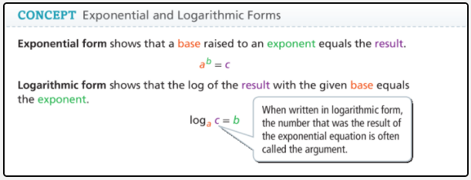

Example 2 Convert Between Exponential and Logarithmic Forms

A. What is the logarithmic form of $3^{4}=81$?

B. What is the exponential form of $\log_{10}{1,000=3}$?

Example 3 Evaluate Logarithms

What is the value of each logarithmic expression?

A. $\log_{5}{125}$ | B. $\log_{\frac{1}{4}}{16}$
C. $\log_{0}{3}$ | D. $\log_{2}{2^{8}}$

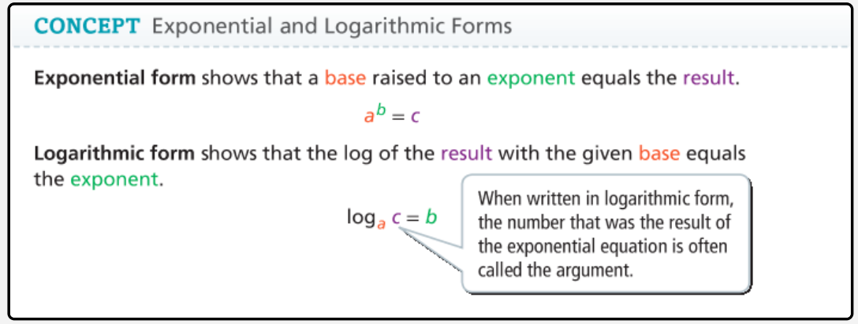

Example 4 Evaluate Common and Natural Logarithms
What is the value of each logarithmic expression to the nearest ten-thousandth?
A. $\log{900}$ B. $\ln{e}$ C. $ln⁡(-1.87)$

Example 5 Solve Equations With Logarithms
What is the solution to each equation? Round to the nearest thousandth.
A. $25={10}^{x-1}$ B. $\ln\left(2x+3\right)=4$

Example 6 Use Logarithms to Solve Problems
The seismic energy, x, in joules can be estimated based on the magnitude, m, of an earthquake by the formula $x={10}^{1.5m+12}$. What is the magnitude of an earthquake with a seismic energy of $4.2×{10}^{20}$?


