Example 6 Use Regression to Find an Exponential Model

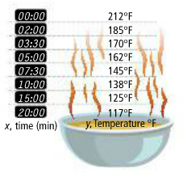
Randy is making soup. The soup reaches the boiling point and then, as shown by the data, begins to cool off. Randy wants to serve the soup when it is about $80°$F, or about 10 degrees above room temperature ($68°$).

A. Explain why the temperature might follow an exponential decay curve as it approaches room temperature.

B. Find an exponential model for the data. Use your model to determine when Randy should serve the soup.

6-2 Exponential Models

Target: I can write exponential models in different ways to solve problems.

Essential Question: How can you develop exponential models to represent and interpret situations?

Example 1 Rewrite an Exponential Function to Identify a Rate
In 2015, the population of a small town was 8,000. The population is increasing at a rate of 2.5% per year. Rewrite an exponential growth function to find the monthly grown rate.

‘

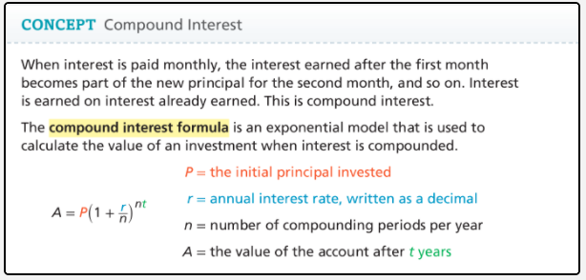
Example 2 Understand Compound Interest
Tamira invests $5,000 in an account that pays 4% annual interest. How much will there be in the account after 3 years if the interest is compounded annually, semi-annually, quarterly, or monthly?

Example 5 Use Two Points to Find and Exponential Model
Tia knew that the number of e-mails she sent was growing exponentially. She generated a record of the number of e-mails she sent each year since 2009. What is an exponential model that describes the data?


Example 3 Understanding Continuously Compounded Interest
Consider an investment of $1 in an account that pays a 100% annual interest rate for one year. The equation $A=1{\left(1+\frac{1}{n}\right)}^{n\left(1\right)}={\left(1+\frac{1}{n}\right)}^{n}$ gives the amount in the account after one year for the number of compounding periods n. Find the value of the account for the number of periods given in the table.

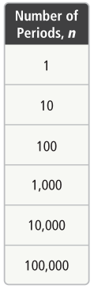

The __________________________________________________ is defined as the value that the expression ${\left(1+\frac{1}{x}\right)}^{x}$ approaches as $x→+∞$. The number e is an irrational number.

e = _________________________________

The number e is the base in the continuously compounded interest formula.

Formula: ____________________
P = __________________________________________________
e = __________________________________________________
r = __________________________________________________
A= __________________________________________________

Example 4 Find Continuously Compounded Interest
Regina invests $12,600in an account that earns 3.2% annual interest, compounded continuously. What is the value of the account after 12 years? Round your answer to the nearest dollar.



