Example 5: Compare Two Exponential Functions
A museum purchased a painting and a sculpture in the same year. Their changing values are modeled as shown. Find the average rate of change of the value of each art work over the 5-year period. Which art work’s value is increasing more quickly?
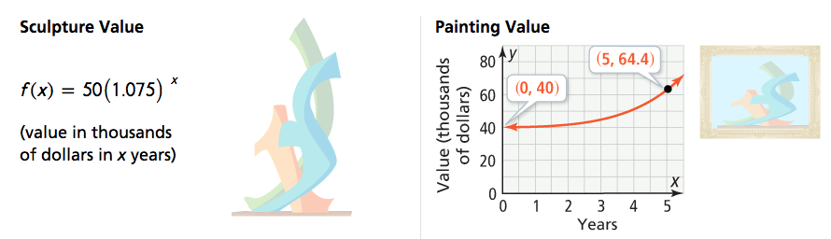

6-1 Key Features of Exponential Functions
Target: I can recognize the key features of exponential functions.

Essential Question: How do graphs and equations reveal key features of exponential growth and decay functions?

An ________________________________________ function is any function of the form $y=a∙b^{x}$ where a and b are constants with $a≠0$, and $b>0, b≠1$.

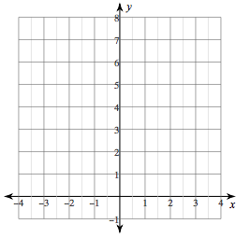

Growth Decay

Example 1: Identify Key Features of Exponential Functions
What are the key features of each function? Include domain, range, intercepts, asymptotes, and end behavior.
A. $f\left(x\right)=2^{x}$ B. $g\left(x\right)=5{\left(\frac{1}{2}\right)}^{x}$

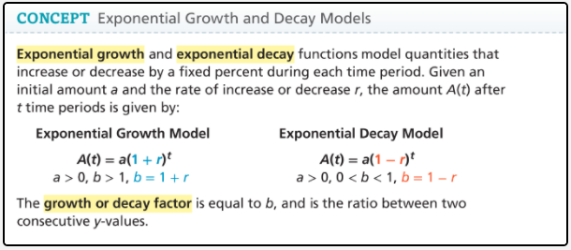

Example 4: Interpret and Exponential Function
A car was purchased for $24,000. The function $y=24∙{0.8}^{x}$ can be used to model the value of the car (in thousands of dollars) x years after it was purchased.

A. Does the function represent exponential growth or decay?

B. What is the rate of decay for this function? What does it mean?

C. Graph the function on a reasonable domain. What do the y-intercept and asymptote represent? When will the value of the car be about $5,000?

Example 2: Graph transformations of Exponential Functions
Graph each function. Describe the graph in terms of transformations of the parent function $f\left(x\right)=3^{x}$. How do the asymptote and intercept of the given function compare to the asymptote and intercept of the parent function?

A. $g\left(x\right)=-3^{x}$
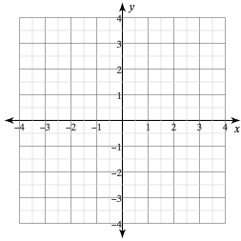

B. $h\left(x\right)=3^{x}-4$

Example 3: Model with Exponential Functions
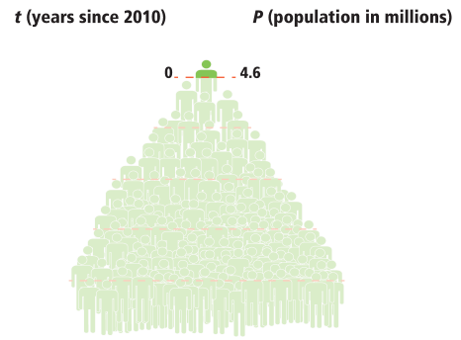

The population of a large city was about 4.6 million in the year 2010 and grew at a rate of 1.3% for the next four years.

A. What exponential function models the population of the city over that 4-year period?

B. If the population continues to grow at the same rate, what will the population be in 2040?

Example 6: Error Analysis
Charles claimed the function $f\left(x\right)={\left(\frac{3}{2}\right)}^{x}$ represents exponential decay. Explain the error Charles made.



