1-3 Piece-wise Defined Functions: Supplemental Materials

Matching Linear Graphs: (Solutions: 4D, 2C, 3B, 1A)

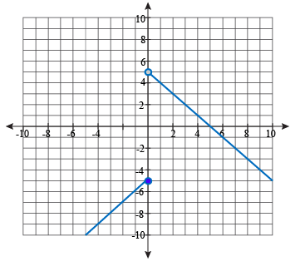  Graph A | 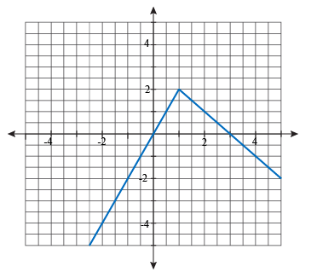  Graph B
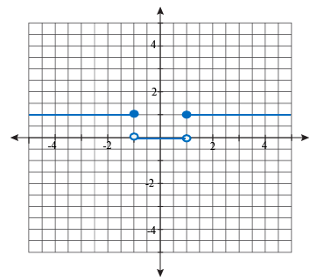  Graph C | 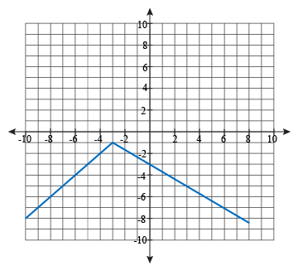  Graph D
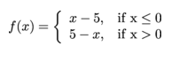  Equation 1 | Equation 2  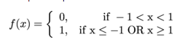
Equation 3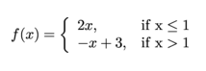 | Equation 4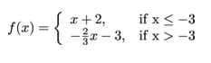
More Linear Examples

Solutions:
- E | - B | - D
- F | - C | - A

Application

The admission rates at an amusement park are as follows.
Children under 5 : free
Children between 5 years and 11 years, inclusive: $10.00
Children between 12 years and 17 years, inclusive: $25.00
Adults: $35.00
a) Write a piecewise function that gives the admission price for a given age.
b) Graph the function.

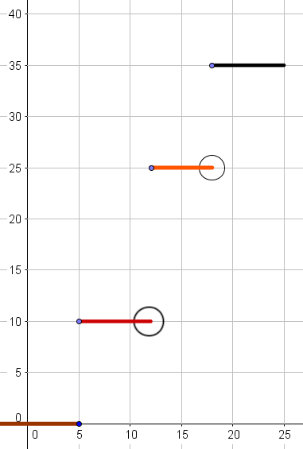
Solutions:

$$f\left(x\right)=\left\{\begin{aligned}0, x≤5 \\ 10, 5≤x<12 \\ \begin{matrix}25, 12≤x<18 \\ 35, x≥18\end{matrix}\end{aligned}\right.$$



