Transformations 3- Way Color Match Name ________________________
Match 1 description and 1 equation and 1 graph.

constant function shifted 3 units down | quadratic function shifted right 1 unit. | linear function flipped upside down | absolute value of x shifted up 2 units | constant function shifted 5 units up
x shifted 2 units down | x squared shifted 3 units down | absolute value of x shifted right 1 unit | absolute value of x flipped upside down and shifted down 3 units | x squared shifted 2 units left
y = x² - 3 | y = l x - 1 l | y = - l x l - 3 | y = x - 2 | y = (x – 1)²
y = l x l + 2 | y = 5 | y = ( x + 2 )² | y = -3 | y = - x
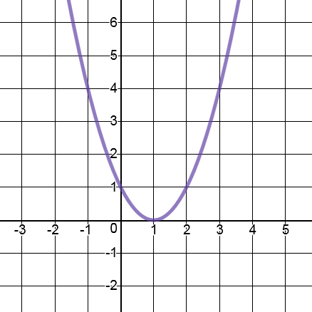 | 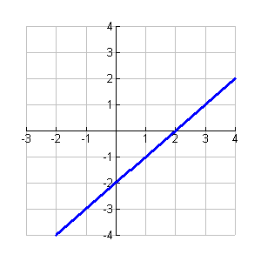 | 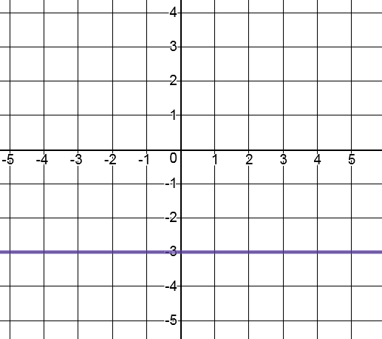 | 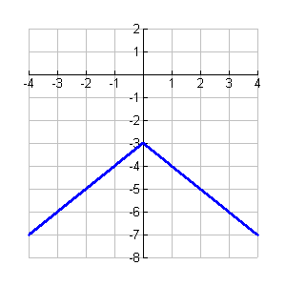 | 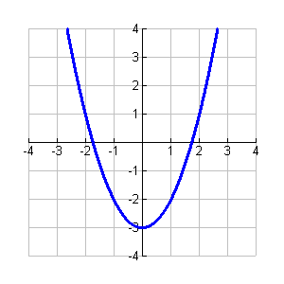
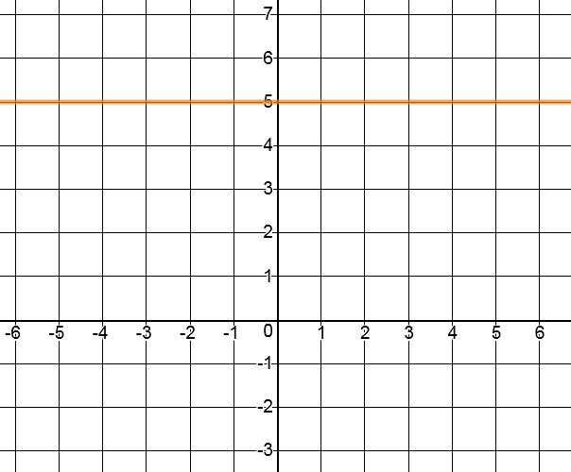 | 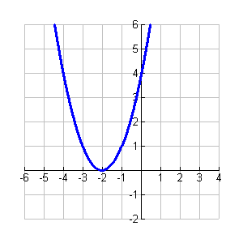 | 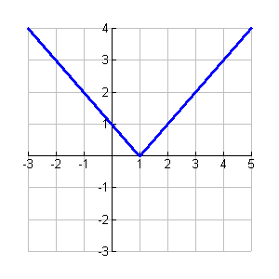 | 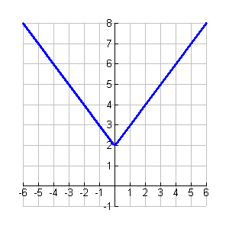 | 

