Card Set A (Graphs)
1  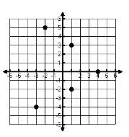 | 2  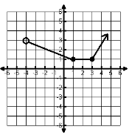 | 3  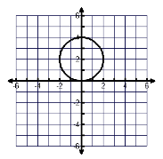
4  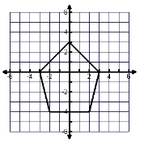 | 5  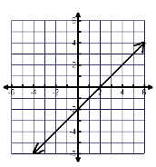 | 6  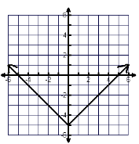
7  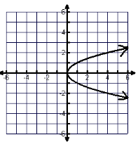 | 8  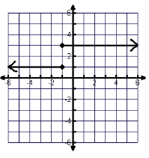 | 9  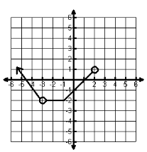
10  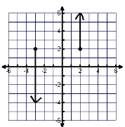 | 11  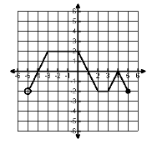 | 12  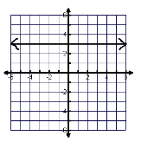
13  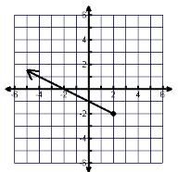 | 14  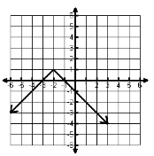 | 15  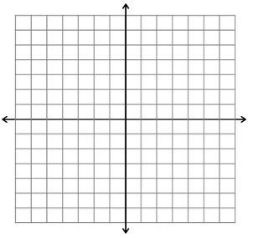
Card Set B (Domain)
Domain  [-4, 0] | Domain  (-∞, ∞) | Domain  (-4, ∞)
Domain  [-3, 3] | Domain  (-5, 5] | Domain  (-∞, ∞)
Domain  (-∞, ∞) | Domain  {-3, -2, 1, 4} | Domain  [0, ∞)
Domain  [-2, 2] | Domain  ______________ | Domain  {-3, 2}
Domain  (-∞, ∞) | Domain  (-∞, 2] | Domain  (-∞, ∞)

Card Set C (Range)
Range  [-2, ∞) | Range  [-2, ∞) | Range  (-∞, 1]
Range  {-4, -2, 0, 3, 5} | Range  [-4, 3] | Range  (-∞, ∞)
Range  [-3, 5] | Range  ______________ | Range  [1, ∞)
Range  (-∞, ∞) | Range  [0, 4] | Range  {1. 3}
Range  [-2, 2] | Range  (-∞, ∞) | Range  {3}

