Key Features of Functions Bump
2 | A function with an x-intercept of -4 |  | Materials: Two die and eight counters per player. Each player uses a different color.
3 | A function with a y-intercept of 3
4 | A function with no x-intercept
5 | A function with a maximum value |  | To play:  - On your turn, roll two die and add.  - Read aloud the clue that matches the number you rolled.  - Use a marker to cover a graph that matches the clue.  - If your partner has already covered the graph, say, “Sorry bump!”  - Your partner will remove his counter, and you will claim the graph.  - You can lock a graph if you roll two clues that describe the shape and stack two counters on that shape. Try to be the first to use all of your counters.  - Be ready to justify your answer to your partner.
6 | A function with a minimum value
7 | A function that is always increasing
8 | A function that is always negative
9 | A function with 2 x-intercepts
10 | A function with an x-intercept that is 2 less than its y-intercept
11 | A function with a constant rate of change
12 | A function with a varying rate of change

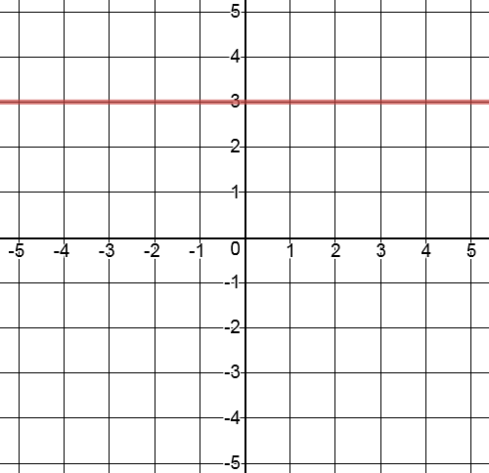 | 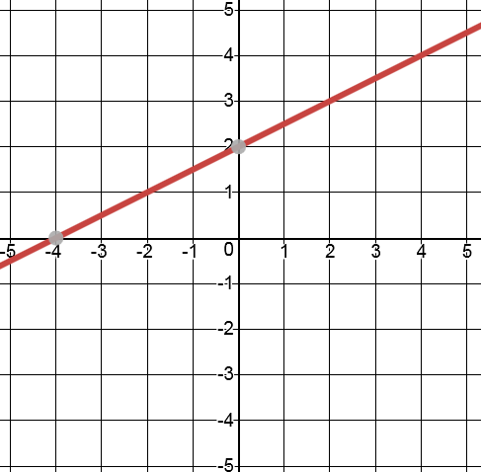 | 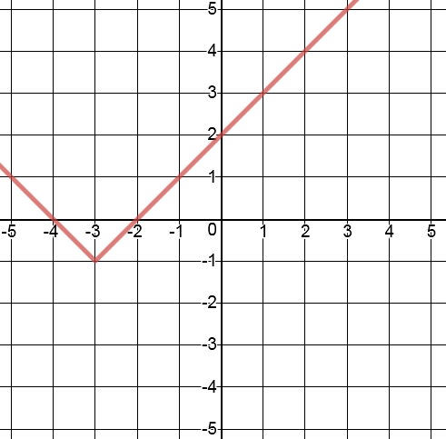 | 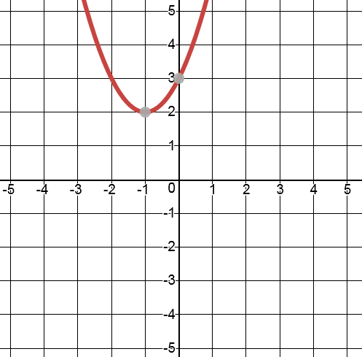
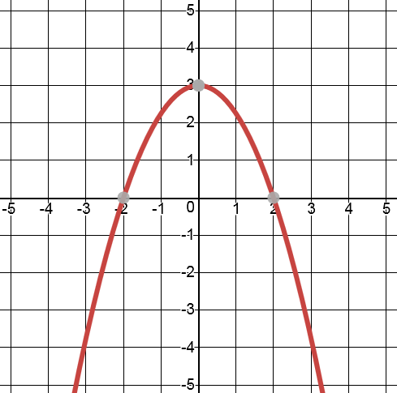 | 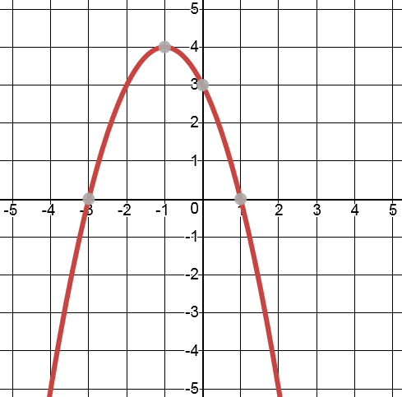 | 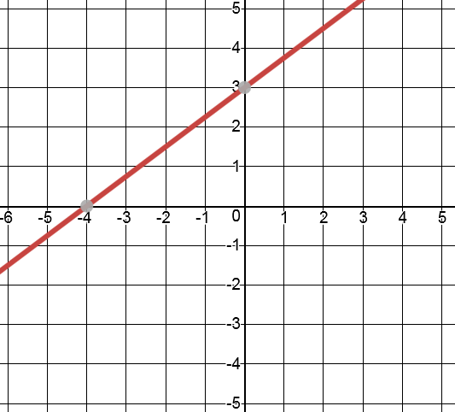 | 

