Lesson 1.7 Absolute Value Equations and Inequalities
Interactive Student Edition

Model & Discuss
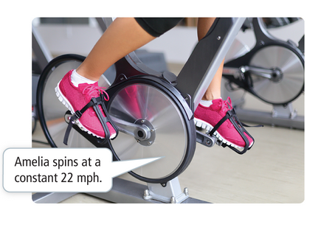
Amelia is participating in a 60-mile spin-a-thon. Her spin bike keeps track of the simulated number of miles she travels. She plans to take a 15-minute break within 5 miles of riding 30 miles.
- Write a compound inequality that models the number of miles Amelia spins before taking a break.
- How is the number of miles Amelia spins before she takes a break related to the amount of time before she takes a break?
HABITS OF MIND
Reason How is the time Amelia spins related to the distance she spins?

LESSON ESSENTIAL QUESTION
Why does the solution of the absolute value equation or inequality typically result in a pair of equations or inequalities?
Example 1 Understanding Absolute Value Equations
- What is the value of $x$ in $7=\left|x\right|+2$?

- What is the value of $x$ in $\left|2x-3\right|=1?$

- What is the value of $x$ in $3\left|x+6\right|+8=5$?

Try It!
- Solve each equation.
- $6=\left|x\right|-2$
- $2\left|x+5\right|=4$
- $\left|3x-6\right|=12$
Example 2 Apply an Absolute Value Equation
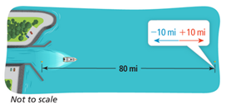
The cruising speed of Kennedy’s boat is 25 mi/h. She plans to cruise at this speed for a distance shown in the diagram.
- What equation models the number of hours $x$ that Kennedy will travel?
The cruising speed of Kennedy’s boat is 25 mi/h. She plans to cruise at this speed for 80 miles, plus or minus 10 miles.
- What are the minimum number and maximum number of hours Kennedy will travel?
Try It!
- The cruising speed of Kennedy’s boat is 20 mi/h and she plans to cruise at this speed for 80 miles, plus or minus 10 miles. What will be the minimum and maximum time that she will travel now?
HABITS OF MIND
Generalize How is solving an absolute value equation similar to solving a regular equation? How is it different?

Example 3 CONCEPTUAL UNDERSTANDING Understanding Absolute Value Ineqalities
What are the soltuions of the absolute value inequality?
- $\left|x\right|<3$
- $\left|x\right|>3$
Try It!
- Solve and graph the solution of the inequality.
- $\left|x\right|>15$
Drag the endpoints of the graph. Then, choose the direction of the graph and the endpoint types.

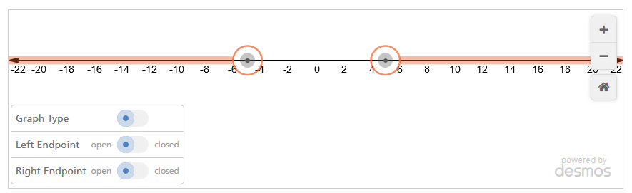

- $\left|x\right|≤7$
Drag the endpoints of the graph. Then, choose the direction of the graph and the endpoint types.
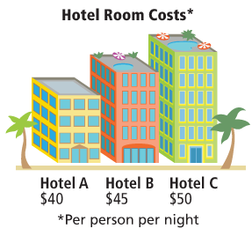
Example 4 APPLICATION Write an Absolute Value Inequality
Members of the debate team are traveling to a tournament, where they will stay in a hotel for 4 nights. The total cost for each member must be within $20 and $175. Which of the hotels shown can they consider?
Try It!
- Members of the debate team are traveling to a tournament, where they will stay in a hotel for 4 nights. The total cost for each member must be within $20 and $200. Will they be able to afford Hotel D at $55 per night? Explain?
HABITS OF MIND
Look for Relationships What do you notice about absolute value inequalities that is similar to compound inequalities?

