Lesson 1.5 Solving Inequalities in One Variable
Interactive Student Edition

Model & Discuss
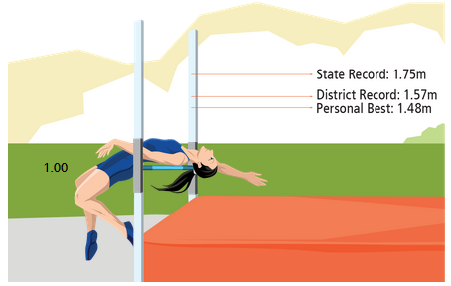
Skylar competes in the high jump event at her school. She hopes to tie or break some records at the next meet.
You can drag Skyler to see possible heights for her high jump bar.
- Write and solve an equation to find x, the number of meters Skyler must add to her personal best to tie the district record.
- Look for Relationships Rewrite your equation as an inequality to represent the situation where Skyler breaks the district record. How does the value of x in the inequality relate to the value of x in the equation?

HABITS OF MIND
Make Sense and Persevere What strategy did you use to answer the questions? What other strategy might you have used?

LESSON ESSENTIAL QUESTION
How are the solutions of an inequality different from the solutions of an equation?
Example 1 Solve Inequalities
Solve $-4\left(3x-1\right)+6x≥16$ and graph the solution.
Try It!
- Solve the inequality and graph the solution.
- $-3\left(2x+2\right)<10$
Drag the endpoint of the graph. Then, choose the direction of the graph and the type of endpoint.
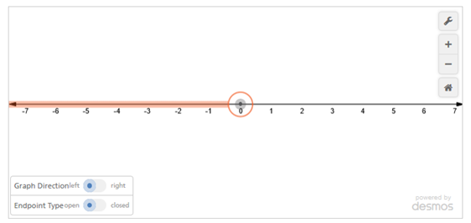
Solve the inequality and graph the solution.
- $2\left(4-2x\right)>1$
Drag the endpoint of the graph. Then, choose the direction of the graph and the type of endpoint.

Example 2 Solve an Inequality With Variables on Both Sides
Solve $3.5x+19≥1.5x-7$. Then graph the solution.
Try It!
- Solve $2x-5<5x-22$. Then graph the solution.
Drag the endpoint of the graph. Then, choose the direction of the graph and the type of endpoint.

Example 3 CONCEPTUAL UNDERSTANDING Understand Inequalities With Infinitely Many or No Solutions
- Solve $-3\left(2x-5\right)>-6x+9$
- Solve $4x-5<2(2x-3)$
Try It!
- Solve each inequality.
- $-2\left(4x-2\right)<-8x+4$
- $-6x-5<-3(2x+1)$

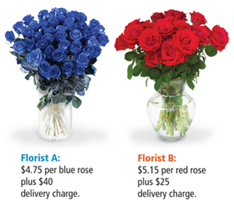
Example 4 APPLICATION Use Inequalities to Solve Problems
Derek wants to order some roses online. From what number of roses is it less expensive to order from Florist A? From Florist B?
Try It!
- Derek wants to order some roses online. Florist A charges $4.75 per blue rose plus $40 delivery charge. Florist B charges $5.15 per red rose plus $25 delivery charge. If Florist B increases the cost per rose to $5.20, for what number of roses is it less expensive to order from Florist A? From Florist B?
HABITS OF MIND
Look for Structure How is solving an inequality with variables on one side similar to and different from solving inequalities with variables on both sides?

