Lesson 1.2 Solving Linear Equations
Interactive Student Edition

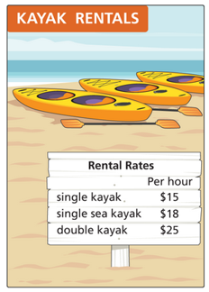
Model & Discuss
Joshua is going kayaking with a group during one of his vacation days. In his vacation planning, he budgeted $50 for a kayak rental. In his vacation planning, he budgeted $50 for a kayak rental.
- How can Joshua determine the number of hours he can rent a kayak for himself? Describe two different options.
- Joshua found out that there is a $25 nonrefundable equipment fee in addition to the hourly rates. How does this requirement change the mathematics of the situation?
- Look for Relationships How do the processes you used for parts A and B differ? How are they the same?
HABITS OF MIND
Make Sense and Persevere How did you determine which operations are needed to solve the problem?

LESSON ESSENTIAL QUESTION
How do you create equations and use them to solve problems?
Example 1 CONCEPTIUAL UNDERSTANDING Solving Linear Equations
What is the value of x in the equation$\frac{2(x+4)}{3}-8=32$?
Try It!
- Solve the equation$4+\frac{3x-1}{2}=9$. Explain the reasons why you chose your solution method.

HABITS OF MIND
Communicate Precisely How can you check that the value of the variable makes the equations true?

Example 2 Solve Consecutive Integer Problems
The sum of three consecutive integers is 132. What are the three integers?
Try It!
- The sum of three consecutive odd integers is 57. What are the three integers?

Example 3 APPLICATION Use Linear Equations to Solve Mixture Problems
A lab technician needs 25 liters of a solution that is 15% acid for a certain experiment, but she has only a solution that is 10% acid and a solution that is 30% acid. How many liters of the 10% and the 30% solutions should she mix to get what she needs?
Try It!
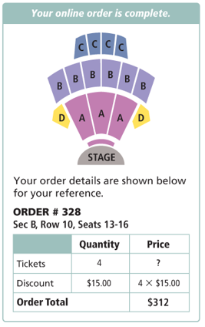
- If the lab technician needs 30 liters of a 25% acid solution, how many liters of the 10% and the 30% acid solutions should she mix to get what she needs?
Example 4 APPLICATION Use Linear Equations to Solve Problems
Four friends use an online code to get discounts on concert tickets. They spent $312 for the four tickets. What was the price of one ticket without the discount?
Try It!
- The same four friends buy tickets for two shows on consecutive nights. They use a coupon for $5 off each ticket. They pay a total of $416 for 8 tickets. Write and solve an equation to find the original price of the tickets.

Example 5 APPLICATION Solve Work and Time Problems
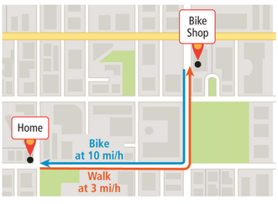
LaTanya will walk her bike from her house to the bike shop, which is 1.5 mi from her house, to get the bike fixed. She expects to wait 30 minutes for the repair. The she will ride her bike home. Can she be home in one hour?
Try It!
- LaTanya leaves her house at 12:30 P.M. and bikes at 12 mi/h to Marta’s house. She stays at Marta’s house for 90 min. Both girls walk back to LaTanya’s house along the same route at 2.5 mi/h. They arrive at LaTanya’s house at 3:30 P.M. How far is Marta’s house from LaTanya’s house?
HABITS OF MIND
Look for Relationships What patterns can you identify in the solution for Examples 3, 4, and 5?

