Lesson 1.6 Compound Inequalities
Interactive Teacher Edition

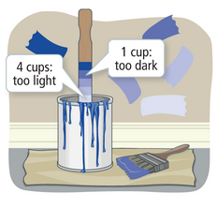
Explore & Reason
Hana has some blue paint. She wants to lighten the shade, so she mixes in 1 cup of white paint. The color is still too dark, so Hanna keeps mixing in 1q cup of white paint at a time. After adding 4 cups, she decides the color is too light.
- Explain in words how much paint Hana should have added initially to get the shade she wants.

- Model With Mathematics Represent your answer in part A with one or more inequalities.

- Hana decides that she likes the shades of blue that appear in between adding 1 cup and 4 cups of white pant. How can you represent the number of cups of white paint that yield the shade Hana prefers?

HABITS OF MIND
Mathematical Modeling If the solution to an inequality includes all the values that are in between two values, how can you show that on a number line?

LESSON ESSENTIAL QUESTION
What are compound inequalities and how are their solutions represented?

$x<-4$ OR $x≥3$ | $x>-1$ AND $x≤4$  $$-1<x≤4$$
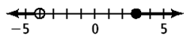 | 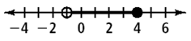

**CAUTION** When multiplying or dividing by a negative, remember to switch the direction of the inequality!

Example 1 CONCEPTUAL UNDERSTANDING Understanding Compound Inequalities
- How can you use inequalities to describe the set of numbers graphed below?
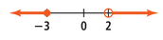

- How can you use inequalities to describe the set of numbers graphed below?
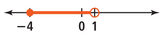

Try It!
- Write a compound inequality for the graph.
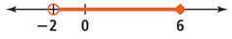

Example 2 Solve a Compound Inequality Involving Or
Solve the compound inequality $5x+7<13$ or $-4x+3>11$. Graph the solution.

Try It!
- Solve the compound inequality $-3x+2<-7$ or $2(x-2)≥6$. Graph the solution.

Drag the endpoints of the graph. Then, choose the direction of the graph and the endpoint types. 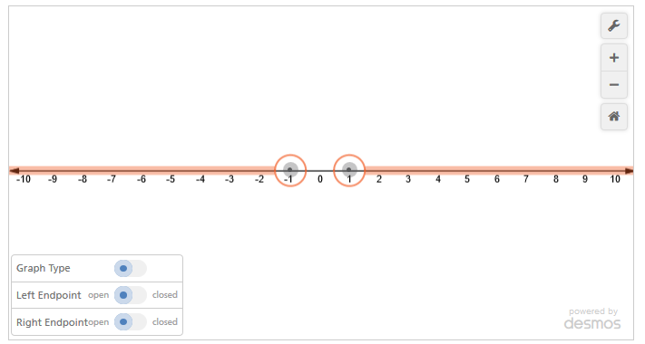
HABITS OF MIND
Make Sense of Problems How does representing a compound inequality solution on a graph help show the solution accurately?

Example 3 Solve a Compound Inequality Involving And
What is the solution of $-12≤7x+9<16$?

Try It!
- Solve the compound inequality $-2\left(x+1\right)<4$ and $4x+1≤-3$. Graph the solution.

Drag the endpoints of the graph. Then, choose the direction of the graph and the endpoint types.
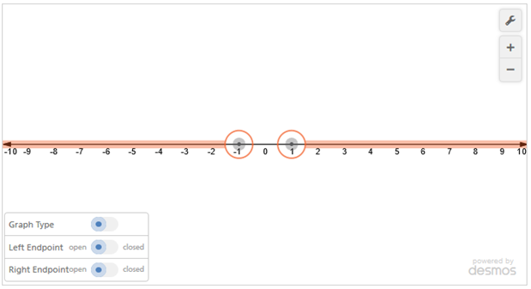
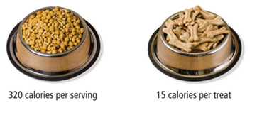
Example 4 APPLICATION Solve Problems Involving Compound Inequalities
Enrique plans a diet for his dog, River. River consumes between 510 and 540 calories per day. If River eats $1\frac{1}{2}$ servings of dog food each day, how many treats can she have?

Try It!
- Enrique plans a diet for his dog, River. River consumes between 410 and 540 calories per day. There are 320 calories in one serving of dog food. River eats $1\frac{1}{2}$ servings of dog good per day. Suppose River has new treats that are 10 calories each. How many of the new treats can she have and remain in her calorie range?

HABITS OF MIND
Communicate Precisely Describe the solution of an inequality involving or and an inequality involving and.

Practice
- Write a compound inequality for the graph.

- Write a compound inequality that represents each phrase. Graph the solution.

- All real numbers that are less than -3 or greater than or equal to 5
- A quantity $x$ is at least than 15 and at most 50.

- Solve and graph each compound inequality
- $3>\frac{11+k}{4}≥-3$

- $6b-1≤41$ or $2b+1≥11$

- $3<2p-3≤12$

- $-x+1>-2$ and $6\left(2x-3\right)≥-6$

