Lesson 1.5 Solving Inequalities in One Variable
Interactive Teacher Edition

Model & Discuss
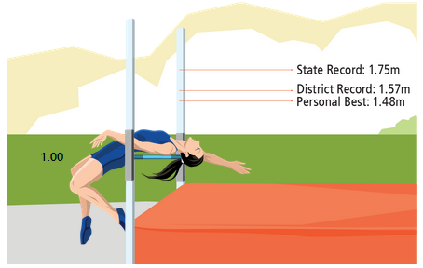
Skylar competes in the high jump event at her school. She hopes to tie or break some records at the next meet.
You can drag Skyler to see possible heights for her high jump bar.
- Write and solve an equation to find x, the number of meters Skyler must add to her personal best to tie the district record.

- Look for Relationships Rewrite your equation as an inequality to represent the situation where Skyler breaks the district record. How does the value of x in the inequality relate to the value of x in the equation?
Teacher note: Have students complete part A on their own. Then have a student share under the document camera or smart board. Before completing part b, drag Skyler to see what heights could be above the district record. Then to go into part b, ask “how can we represent all these heights?”

HABITS OF MIND
Make Sense and Persevere What strategy did you use to answer the questions? What other strategy might you have used?
Teacher note: Choose one or two of Habits of Mind to focus on during lesson. Write them on the board. As the lesson goes on, have them add ideas to the question.

LESSON ESSENTIAL QUESTION
How are the solutions of an inequality different from the solutions of an equation?
Teacher note: The essential question should be the idea you keep coming back to the entire lesson.

Symbol | Meaning | Graphed | Example | Graphed Solution Set
$$>$$ | is greater than | “open” | $x>4$ or $4<x$
$$≥$$ | is greater than or equal to | “closed” | $x≥4$ or $4≤x$
$$<$$ | is less than | “open” | $x<4$ or $4>x$
$$≤$$ | is less than or equal to | “closed” | $x≤4$ or $4≥x$
Teacher note: In the table above review the inequalities, their meaning and their graph.
In the quick review, ask students to complete on their own. Circulate and check, this will give you an idea who is missing the inequality foundation.
Quick Review Translate the verbal expression into a mathematical inequality.
- 3 less than a number $n$ is greater than 9.

- The length of a fish is less than 3 feet.

- A person must be over 42 inches tall to ride.

**CAUTION** When multiplying or dividing by a negative, remember to switch the direction of the inequality!

Example 1 Solve Inequalities
Solve $-4\left(3x-1\right)+6x≥16$ and graph the solution.

Try It!
Teacher Note: Complete Try It! 1 and 2 in student companion. Have the students check with their partner. Then have a pair come to the board and complete the problem together and complete the Desmos Graph in the interactive student edition.
- Solve the inequality and graph the solution.
- $-3\left(2x+2\right)<10$

Drag the endpoint of the graph. Then, choose the direction of the graph and the type of endpoint.
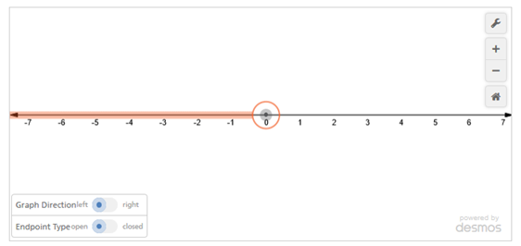
Solve the inequality and graph the solution.
Teacher note: On Try It b, it is a common mistake for students to want to add 8 to both sides instead of subtract.
- $2\left(4-2x\right)>1$

Drag the endpoint of the graph. Then, choose the direction of the graph and the type of endpoint.
Example 2 Solve an Inequality With Variables on Both Sides
Solve $3.5x+19≥1.5x-7$. Then graph the solution.
Teacher note: If you feel like the students getting a fraction in the problem will take away from their confidence, change the problem.
Have students try the problem completely on their own for two minutes. After the time is up, have them ask their partner for help.
Instead of going over every step, go over it to a point where you feel they should be able to solve it by themselves.

Try It!
- Solve $2x-5<5x-22$. Then graph the solution.

Drag the endpoint of the graph. Then, choose the direction of the graph and the type of endpoint.

Decide if each of the following is a true or false statement.
$$5<9$$ | $$3>3$$
$$0≥5$$ | $$5≤5$$

Infinite Solutions or No Solutions (number = number)
True Statement | All Real Numbers
False Statement | No Solution

Example 3 CONCEPTUAL UNDERSTANDING Understand Inequalities With Infinitely Many or No Solutions

- Solve $-3\left(2x-5\right)>-6x+9$

- Solve $4x-5<2(2x-3)$

Try It!
Teacher note: Have students complete the Try It 3 with boss-secretary. They will need to discuss why the answer is infinite or no solution. Because it is boss-secretary, they will only complete 1 in their Student Companion.
If you are running short on time, just pick one for them to do.

- Solve each inequality.

- $-2\left(4x-2\right)<-8x+4$

- $-6x-5<-3(2x+1)$

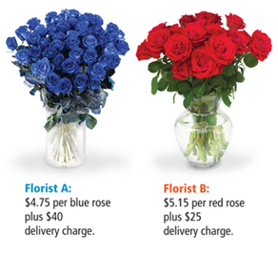
Example 4 APPLICATION Use Inequalities to Solve Problems
Derek wants to order some roses online. From what number of roses is it less expensive to order from Florist A? From Florist B?

Try It!
- Derek wants to order some roses online. Florist A charges $4.75 per blue rose plus $40 delivery charge. Florist B charges $5.15 per red rose plus $25 delivery charge. If Florist B increases the cost per rose to $5.20, for what number of roses is it less expensive to order from Florist A? From Florist B?
Teacher note: When doing word problems ask:
Do you want more than ____?
Do you want less than ____?
Do you want exactly _____?
This will help them decide what inequality they want.

If you are short on time, just have the students set up the Inequality.

HABITS OF MIND
Look for Structure How is solving an inequality with variables on one side similar to and different from solving inequalities with variables on both sides?
Teacher note: Refer to the Concept Summary on page 33 as an recap for the lesson.
Watch your time! You want to save time for student practice. For classwork practice, you will want to do whiteboard or 2-1-0. It needs to be something where you can check their work. In this section, you need to check to see if students can solve the inequality correctly and understand how to graph. Use stronger students as student helpers to help check work and correct minor mistakes.

Practice
- $-3x+9>15$
- $-x-1<3x+1$
- $22≥5\left(2y+3\right)-3y$
- $2\left(n-3\right)≤-13+2n$
- $2\left(3x+7\right)-6x>12$
- An office manager is selecting a water delivery service. Acme H₂O charges $15 fee and $7.50 per 5-gallon jug. Best Water charges a $24 fee and $6.00 per 5-gallon jug. How many 5-gallon jugs will the office have to buy each month for the cost of Best Water to be less than that of Acme H₂O?

