Lesson 1.1 Operations of Real Numbers
Interactive Student Edition

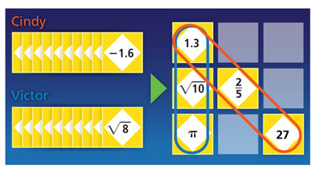
Critique & Explain
Cindy and Victor are playing a math game. The winner must get three in a row of the same type of real number and justify how the numbers are alike. Cindy said she won because she was able to get three rational numbers on a diagonal. Victor said he won with three positive numbers in a column.
- Can both plays say they won, for different reasons? Explain.

- Reason Can you make other groups using the numbers shown that are all the same kind of real number? In how many ways can you do this? You can drag the cards to help solve the problem.

LESSON ESSENTIAL QUESTION
How can you classify the results of operations on real numbers?

A set is a collection of objects such as numbers. An element of a set is an object in the set. A subset is a group of elements from a larger set.

Example 1 Understanding Sets and Subsets
In the set of numbers from 1 to 10, which elements in both the subsets of even numbers, and the subset of multiples of 5?

Try It!
- Which numbers in set A = {1, 2, 3, 4, 5, 6, 7, 8, 9, 10} are elements in both the subsets of odd numbers and the subsets of multiples of 3?

HABITS OF MIND
Generalize Can a number of a set also be a number of more than one subset? Explain.

- Place the following numbers in the most specific box they belong to.

12, -5.013, $\sqrt{21}$ , $\frac{1}{3}$ , 0 , $\sqrt{3}$ , -5

Real Numbers
Rational Numbers |  |  |  | Irrational Numbers
 | Integers |  |  | Irrational Numbers
 | Integers | Whole Numbers |  | Irrational Numbers
 | Integers | Whole Numbers | Natural Numbers | Irrational Numbers

Example 2 APPLICATION Comparing and Ordering Real Numbers
Jim is playing a math game where he needs to put a set of three cards in numerical order. His cards show $\frac{40}{11}, \sqrt{\frac{324}{36}},$and $\sqrt{10}$. Order the cards from least to greatest.

Try It!
- Order each set of cards from least to greatest.

- $0.25, \sqrt{\frac{1}{9}},\frac{6}{25}$

- $\sqrt{\frac{121}{25}}, 2.25,\sqrt{5}$

Operations of Rational and Irrational Numbers

Operation | Two Rational Numbers |  | Rational and Irrational Number
Addition
Subtraction
Multiplication
Division

Example 3 CONCEPTUAL UNDERSTANDING Operations With Rational Numbers

- Is the sum of two rational numbers always a rational number?

- Is the product of two rational numbers always a rational number?

Try It!
- Is the quotient of two rational numbers always a rational number? Explain.

Example 4 Operations With Rational and Irrational Numbers

- Is the sum of a rational number and an irrational number a rational or irrational number?

- Is the product of a rational number and an irrational number rational or irrational?

Try It!
- Is the difference of a rational number and an irrational number always irrational? Explain.

HABITS OF MIND
Reason When is the square root of a number irrational? Give an example. | 

Practice
- In the given set of numbers, which elements are in both the subset of numbers divisible by 2 and the numbers divisible by 3?
$$A=\{5, 6, 7, 8, 9, 10, 12\}$$

- For each of these expressions, draw a line or lines to show the most specific subset which the solution belongs.
- $0-10$ | Irrational Numbers
- $-3+\sqrt{3}$ | Rational Numbers
- $\frac{5}{12}+4\frac{1}{3}$ | Integers
- $7-\sqrt{49}$ | Whole Numbers

- Order the numbers shown from least to greatest.
$$\sqrt{\frac{60}{6}},\sqrt{8}, π$$

- Describe the error each student makes.

- Cameron says the sum of 11.2 and 19 will be irrational because 11.2 is not a rational number.

- Ella says the product of 5 and $\left(\sqrt{9}\right)$ is an irrational number.

- Determine whether the result of the operation will be rational or irrational. Fill in rational or irrational in each blank.
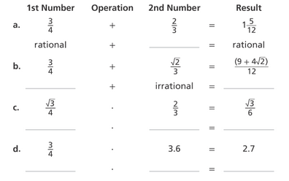
HOMEWORK: p. 9 #16 – 23 all, 28, 30, 32, 33

