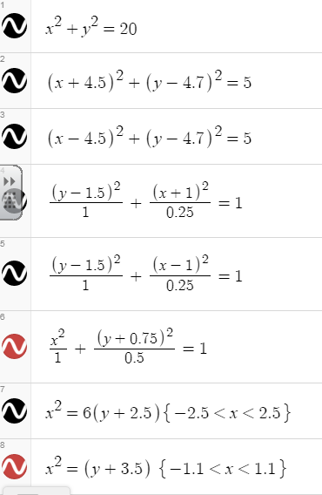
Conics Pictures

1. Log in to your computer
2. Go to desmos.com
3. Graph the equations to left – use one in each box
What image did you create?
____________________________

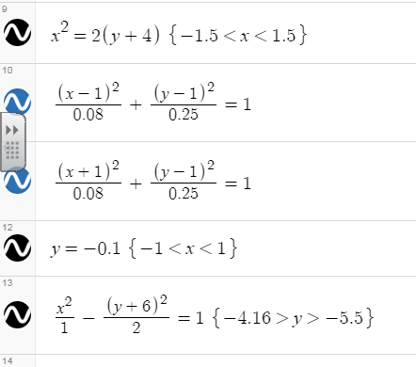

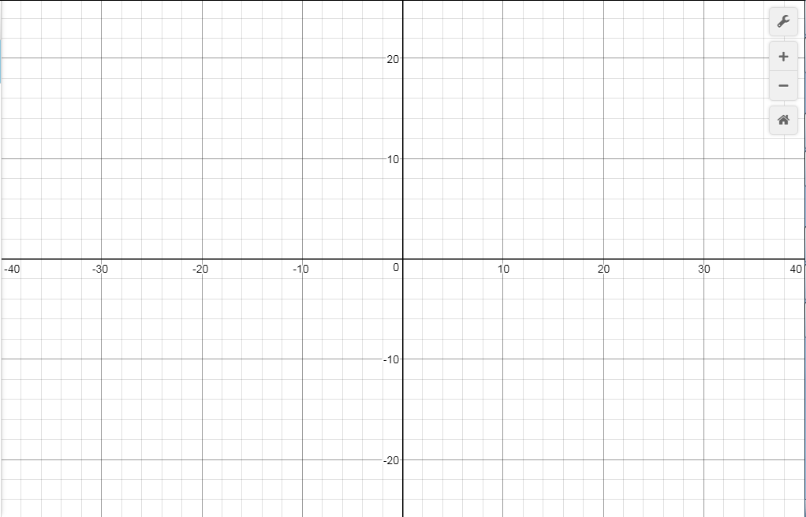
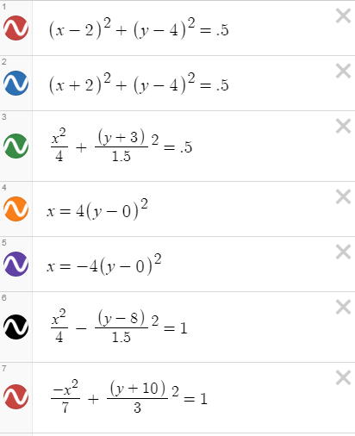
1. Click the three lines on the top left of the screen
2. Choose ‘new blank graph’
3. Graph the equations to the right – use one in each box
What image did you create?
____________________________
4. Sketch your picture below.

