Activity: Introduction to Polynomials
For each graph below, find the equation, type, and degree cut out. Paste them in the space provided. (Be careful with your graphing window.)

1. | equation
 | degree
 | type
2.  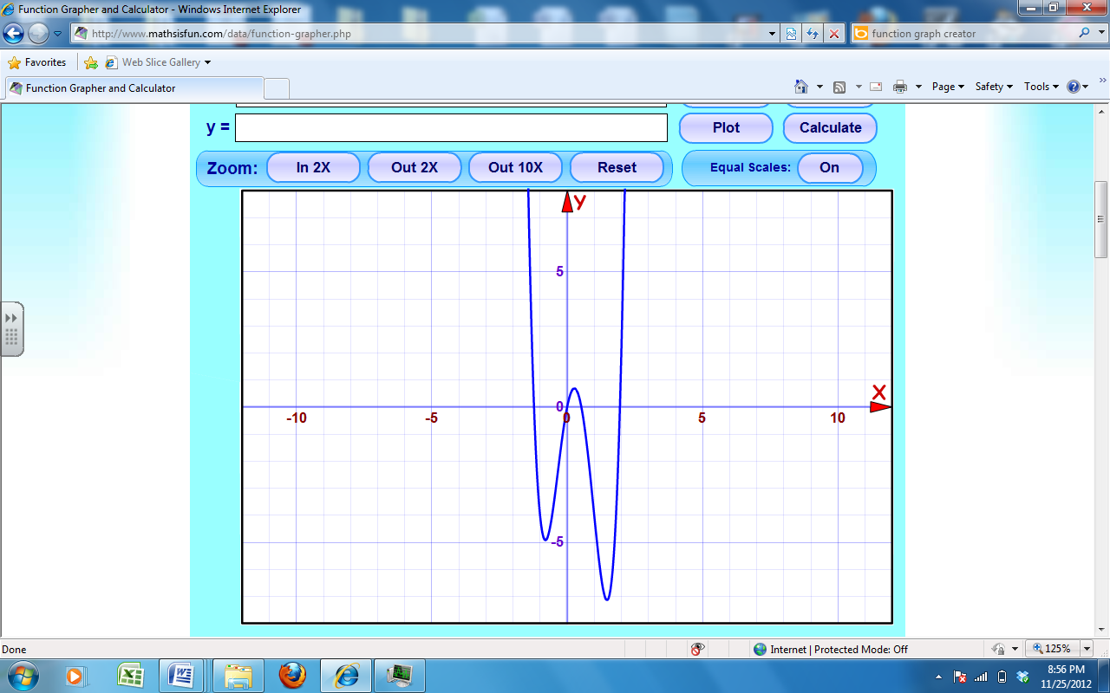 | equation
 | degree
 | type
3. | equation
 | degree
 | type
4. | equation
 | degree
 | type
5. | equation
 | degree
 | type

6. | equation
 | degree
 | type
7. | equation
 | degree
 | type
8. | equation
 | degree
 | type
9. | equation
 | degree
 | type
10. | equation
 | degree
 | type

monomial | quartic
binomial | quartic
trinomial | quartic
trinomial | quartic
trinomial | quartic
trinomial | y = x⁵
polynomial | y = -x⁴ + 1
polynomial | y = 2x³ – 4x² + 1
polynomial | y = -2x³ – x² + 1
polynomial | y = x⁵ – x⁴ + x³ – x² – 4x – 1
cubic | y = -3x⁴ + 8x² + 1
cubic | y = x⁴ + 3x³ – x² – 3x
cubic | y = x⁴ – 3x² + 2
quintic | y = 4x⁴ – 5x³ – 8x² + 5x
quintic | y = $- \frac{1}{10}$x³ - $\frac{3}{10}$x² + $\frac{9}{5}$x + 4

