Bump
Trig Values of Angles D
$$\frac{\sqrt{3}}{2}$$
1/2
2
und
$$\frac{\sqrt{2}}{2}$$

$$\frac{2\sqrt{3}}{3}$$
0
1
$$\sqrt{2}$$
$$\frac{\sqrt{3}}{3}$$

$$\sqrt{3}$$

Materials: One spinner and eight counters per player. Each player uses a different color.
To play: Players take turns spinning. Once a player spins for trig function and angle, the player evaluates the trig value. The player covers this value. If another player has one counter on this number, they can bump that counter off and put one of their own counters on it. You can only “bump” when there is only one counter on the number. If that number is covered by one of the player’s own counters, they can add another counter on top and then they have won that space and no more counters can be added. The winner of the game is the first player to use all eight of their counters.

Trig Function Bump Spinner
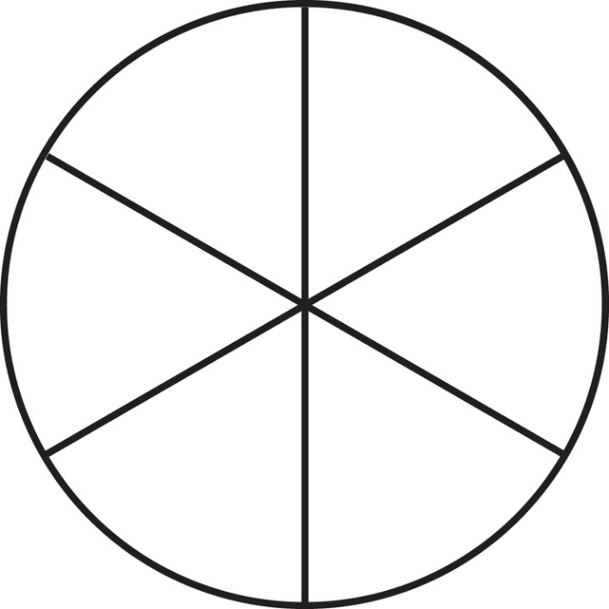
Sin Cos

Tan Cot

Sec Csc

Angle Bump Spinner
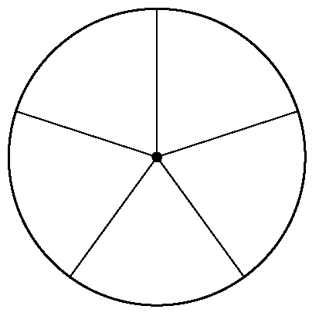
0⁰ 60⁰

30⁰ 90⁰
45⁰

