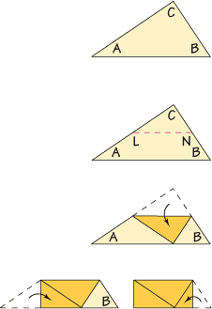
Investigation: Midsegments of Triangles
Draw, label, and cut out a large scalene triangle. Label the vertices A, B, and C.
- Fold A onto C to find the midpoint of .
- Do the same for .
- Label the midpoints L and N, then draw .
- Fold each triangle on .
- Fold A to C. Fold B to C.
- How does LN compare to AB? Explain.
- Make a conjecture about how the segment joining the midpoints of two sides of a triangle is related to the third side of the triangle.

A midsegment is ___________________________________________________________________
The midsegment is:
1. _______________________________________________________________________________
2. _______________________________________________________________________________
List the three pairs of parallel segments:
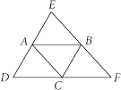

Homework: Midsegments
Find the value of each variable:

