1.5 Basic Constructions
The ancient Greeks were able to draw almost any geometric figure with the tools shown to the right: ________________________ and _________________________.
Constructing Congruent Segments
Given: Construct: so that
- Draw a ray with endpoint C.
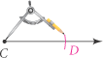
- Open the compass to the length of . 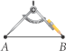
- With the same compass setting, put the compass point on point C.
- Draw an arc that intersects the ray.
- Label the point of intersection D.

Practice: Construct segments congruent to each of the following.

Constructing Congruent Angles
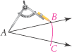
Given: A 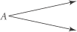 Construct: S so that S A
- Draw a ray with endpoint S.
- With the compass point on point A, draw an arc that intersects the sides of A. Label the points of intersection B and C.
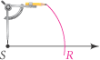
- With the same compass setting, put the compass point on point S.
Draw an arc and label its point of intersection with the ray as R.
- Open the compass to the length BC.
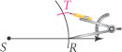
Keeping the same compass setting, put the compass point on R.
Draw an arc to locate point T.
- Draw . 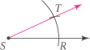

Practice: Construct angles congruent to each of the following.

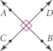
_______________________ ______________ are two lines that intersect to form right angles.
The symbol _______ means __________________________________________.
We say that__________________________ and ________________________.

A __________________________ _____________________________ of a segment is a line, segment, or ray that is perpendicular segment at its midpoint.
To Construct the Perpendicular Bisector of a Segment:
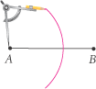
Given: Construct: so that at the midpoint M of .
- Put the compass point on point A and draw a long arc as shown.
Be sure the opening is greater than AB.
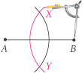
- With the same compass setting, put the compass point on point B and draw another long arc.
Label the points where the two arcs intersect as X and Y.
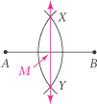

- Draw The point of intersection of and is M, the midpoint of .
at the midpoint of , so is the perpendicular bisector of .

Bisect each segment below:

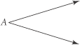
Construct the Bisector of an Angle:
Given: A Construct: , the bisector of A
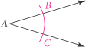
- Put the compass point on vertex A. Draw an arc that intersects the sides of A.
Label the points of intersection B and C.
- Put the compass point on point C and draw an arc. With the same compass setting,
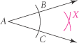
draw an arc using point B. Be sure the arcs intersect.
Label the point where the two arcs intersect as X.
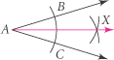
- Draw .
is the bisector of CAB.

Practice: Construct the bisector of each angle.

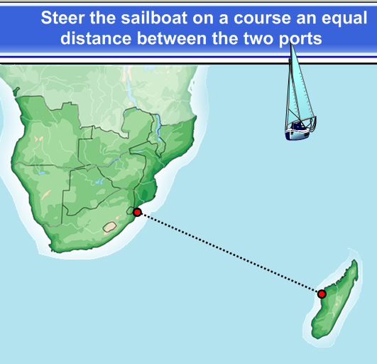
Which construction do you need?

Construct the path.

