Geometry Read and Try: Types of Polygons
Read the following passage about polygons:
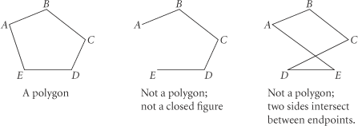
A polygon is a closed plane figure with at least three sides. The sides intersect only at their endpoints, and no adjacent sides are collinear.

To name a polygon, start at any vertex and list the vertices consecutively in a clockwise or counterclockwise direction.
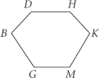
Two names for this polygon are DHKMGB and MKHDBG.
The vertices are: D, H, K, M, G, B
The sides are: , , , , ,
The angles are: D, H, K, M, G, B

You can classify a polygon by the number of sides it has.
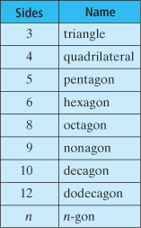
The table at the right shows the names of some common polygons.
Polygons are classified as convex or concave.
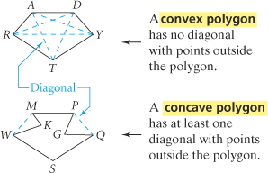

Try these problems:


